Challenge 3: What do frontier safety frameworks actually commit to?
Wisdom Okechukwu · 9 November 2026
Short answer. Less than they appear to. Of 13 companies with a published framework, 8 set a specific danger level for at least one of the five risks, and every one of those also says what it will do when that level is reached. Only 2 (Anthropic and G42) go all the way on any risk: they name who decides, commit to outside review, and say what happens if their safeguards fall short. The missing piece is outside review. Naver and Samsung publish frameworks that name none of the five risks.
Each framework is scored on five risks. For each risk it climbs a ladder, and a step counts only if every step below it is also met:
- Mentioned. The framework names the risk as one the company considers, tests for or tracks.
- Threshold. It also defines a specific level for that risk, in terms of what a model could do, at which the company will act differently.
- Response. It also commits to what the company will do when the level is reached: named safeguards or security measures, or holding back release or development. "May", "consider", "intend" and "as appropriate" do not count, and nor does anything the framework calls illustrative.
- Accountability. It also names who decides, commits to review by someone outside the company (not just "as needed"), and says what happens if the response cannot be met. All three are needed.
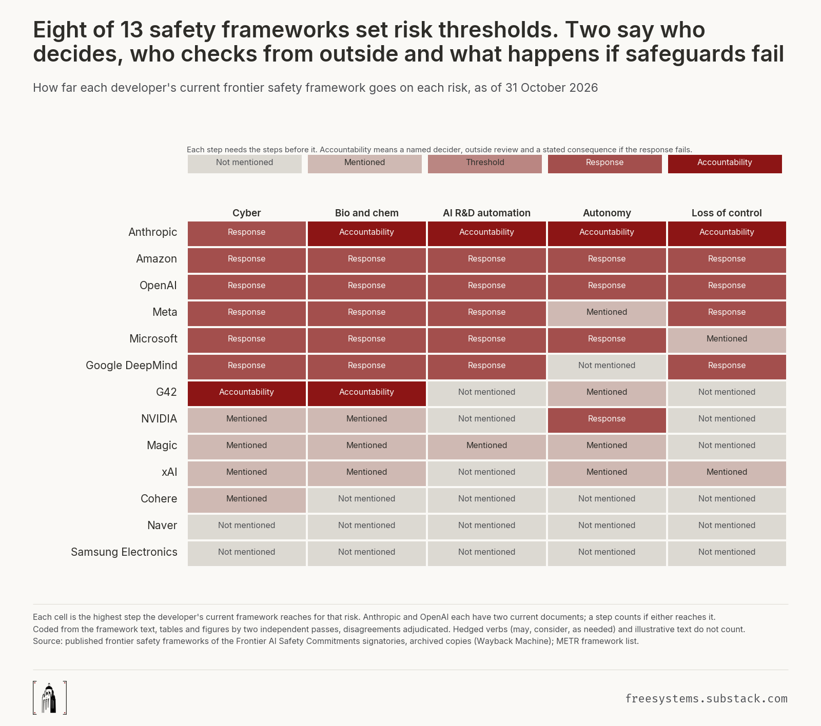

What we found
1. Naming a risk is easy; setting a level is not. Cyber is named by 11 of the 13 frameworks, but only 7 set a cyber danger level. Bio and chem: named by 10, a level from 7. AI R&D automation gets a level from 6, autonomy and loss of control from 5 each. 5 frameworks never set a level for any risk: Cohere, Magic, Naver, Samsung and xAI. Magic's has a table headed "Critical Capability Threshold", then calls the rows "illustrative".
2. Where there is a level, there is a response. Every framework that sets a level also commits to a response. Some go the other way: in 11 cases a framework commits to a response for a risk it never sets a level for. xAI's June 2026 framework says it "will only proceed" if risks are "determined to be acceptable", but defines no level for any risk, so the promise has nothing to measure against.
3. Almost nobody commits to outside review. Of the 8 frameworks with a level and a response, 7 name who decides and 6 say what happens if the response fails, but only 2 commit to any binding review from outside the company. Amazon, Google DeepMind, Meta, Microsoft, NVIDIA and OpenAI make no binding commitment. Most mention outside experts, but on the company's terms: Google DeepMind involves them "as needed", Amazon runs external evaluations "as appropriate", and OpenAI's third-party audits sit in an appendix it calls "illustrative". If a named decider plus one of the other two parts were enough, 6 companies would reach the top step instead of 2.
4. Anthropic's main policy dropped cyber. Anthropic's Responsible Scaling Policy named cyber in every version up to 2.2. From version 3.0 (February 2026) it does not mention cyber at all. Anthropic still covers cyber in a second document written for California's SB 53 law, which is why its cyber cell shows a response.

How the frameworks changed
All 40 published versions were scored the same way. Between one version and the next, a risk went up a step 15 times and down 17 times. The drops:
- OpenAI (April 2025) turned its binding third-party audits into an illustrative appendix, and moved autonomy and loss of control out of its tracked risks into "research categories" with no danger levels.
- Google DeepMind removed autonomy in February 2025 and marked its misalignment levels "illustrative only" in September 2025.
- Anthropic removed cyber from its main policy in February 2026.
- Amazon (September 2026) changed outside evaluation from a commitment to "as appropriate".
- xAI (June 2026) removed its numeric limits for bio and chem and for model dishonesty, and stopped naming AI R&D.
- Naver (July 2026) replaced its named risks with three "protected values"; cyber, bio and chem, and loss of control are no longer named.
Some steps went up too: Anthropic added a loss of control level in February 2026, Google DeepMind in April 2026, Meta in its April 2026 framework and Amazon in September 2026. Every change was checked with both versions side by side. Appendix A shows every version.

How it was done
- Which frameworks. Every framework published by the 20 companies that signed the 2024 Seoul safety commitments, up to 31 October 2026: 40 versions from 13 companies. The other seven were searched and have none: Mistral, TII, MiniMax and 01.AI publish nothing; IBM, Inflection and Zhipu publish only general material.
- Which version. Every file was downloaded and fingerprinted, and archived copies were checked for files replaced in place. The list has 6 versions METR's list does not, including OpenAI's original v2 file: the copy METR links is a quiet re-issue that dropped a safeguard but kept its original date.
- Coding. Two AI coders, Claude Opus 5.5 and Claude Sonnet 5.5, each read every page of every document separately and scored all 1,200 cells. Every "yes" had to quote the document word for word, checked by a script. Separate Claude instances settled the 95 disagreements, re-checked every change between versions with both versions open, and applied three rules added after a review to every document.
- Agreement. Before the disagreements were settled, the two coders agreed well on most steps (Cohen's kappa, where 1 is perfect: mentioned 0.95, threshold 0.868, decider 0.82, outside review 0.793, consequence 0.88). They agreed less on the response step (0.663), so that step leans most on the later rulings.
- Check. Another Claude instance re-checked 60 randomly chosen codes against the documents: 57 correct, 1 wrong and 2 unsure.
- Yardstick. What counts as a specified response follows the EU General-Purpose AI Code of Practice, Safety and Security chapter.

Limits
Gaps in the public record.
- One version could not be found: Anthropic's compliance framework v1.2 (June 2026) was replaced online and never archived.
- A few dates rest on archive captures and file data rather than a printed date: OpenAI's governance framework (May 2026), Microsoft's February 2026 update, and the quiet re-issues by OpenAI and Meta.
Choices in this study.
- The brief asks for two people to code at least a quarter of the cells. Here two AI coders coded all of them and no human audited the codes. Two coders from one model family can share blind spots.
- The top step needs all three parts of accountability, and outside review must be a commitment, not "as needed". Both are strict readings; the looser result is given above.
- Where a company has two current documents (Anthropic and OpenAI), a step counts if either reaches it.
- Samsung is included because its "AI Safety Framework" is the document it published for the Seoul commitments, even though it covers only on-device AI.

Sources and data
Framework documents from each company and the Wayback Machine; METR's list of frontier AI safety policies and its Common Elements report; the Frontier AI Safety Commitments; the EU Code of Practice Safety and Security chapter.
Data and code. Every document's fingerprint and source, both coders' files, every quote, the full method and the code behind each chart: https://github.com/owizdom/rung.

Appendix A. Every version
Each row is one published version, scored on its own.
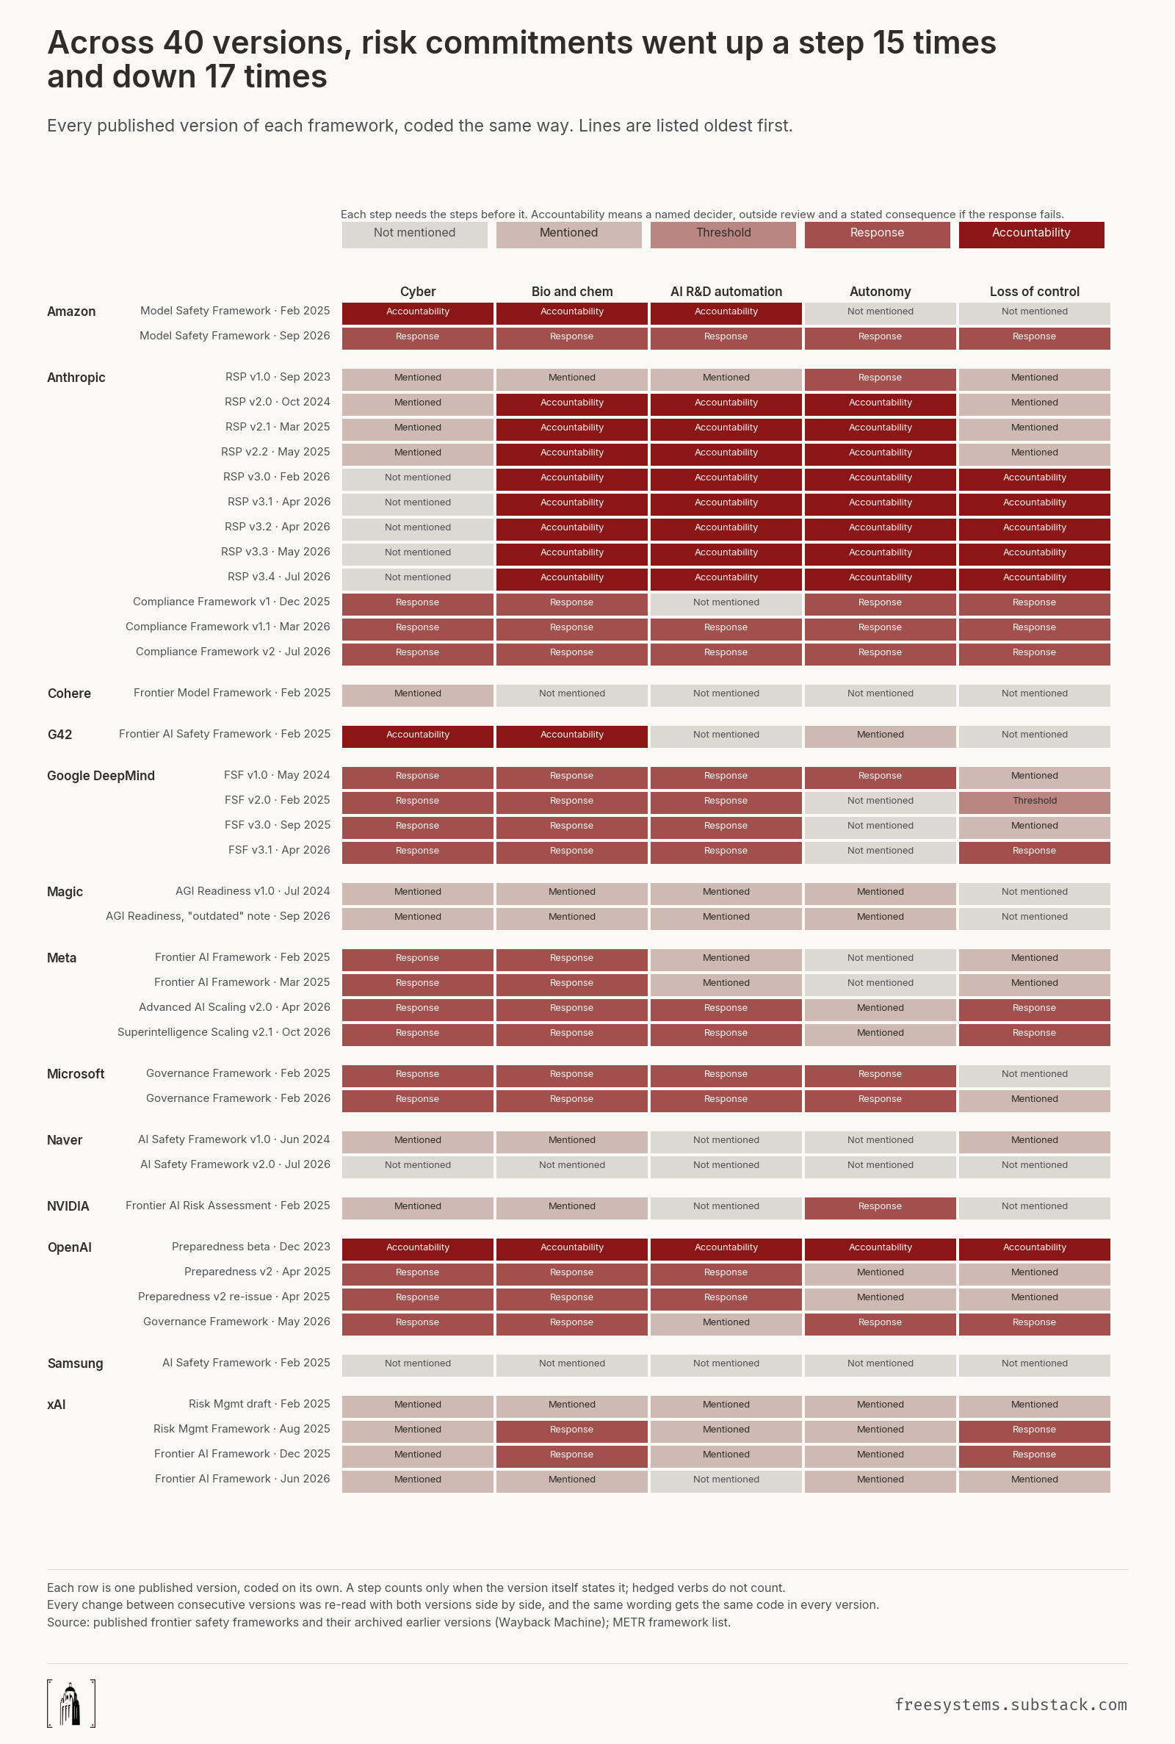

Appendix B. Definitions
Term | Meaning
The five risks
Cyber | Helping carry out cyberattacks: finding or exploiting vulnerabilities, malware, attacks on infrastructure.
Bio and chem | Helping make or use biological or chemical weapons, including CBRN named as one group.
AI R&D automation | Automating or greatly speeding up AI research itself, including AI improving AI.
Autonomy | The model acting on its own in the world: copying itself, gathering resources, long tasks without people.
Loss of control | The model working against its developer's intent, or people losing the ability to correct or shut it down: misalignment, deception, sabotage, escaping oversight.
The steps
Not mentioned | The framework does not name the risk.
Mentioned | The framework names the risk as one the company considers, tests for or tracks.
Threshold | It also defines a specific level for that risk, in terms of what a model could do, at which the company will act differently.
Response | It also commits to what the company will do when the level is reached: named safeguards or security measures, or holding back release or development. "May", "consider", "intend" and "as appropriate" do not count, and nor does anything the framework calls illustrative.
Accountability | It also names who decides, commits to review by someone outside the company (not just "as needed"), and says what happens if the response cannot be met. All three are needed.

